Me llamo _______________________________________ TAREA

INSTRUCCIONES: Choose one of three ways to practice our new vocabulary.

Opción 1: Draw and label 12 of the vocabulary words (preferably those which you don’t already know) It could be one picture (for example a map or a landscape) or 12 smaller pictures.

Opción 2: Choose 12 words (preferably those which you don’t already know). Write them three times in Spanish and once in English.

Opción 3: Quiz yourself with flash cards, use the online flash cards or have an adult quiz you for at least 10 minutes. Have an adult sign below to confirm your practice. Here is the link for Quizlet online flash cards: http://quizlet.com/18899663/visitando-sudamerica-flash-cards/

Adult signature: ___________________________________________________________

EL VOCABULARIO: VISITANDO SUDAMÈRICA

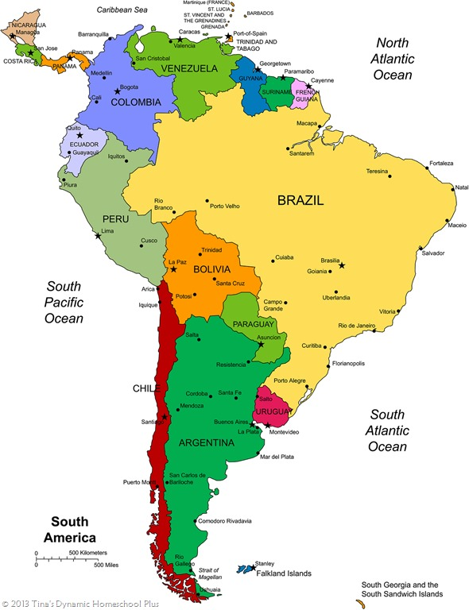

los continentes - continents
los océanos - oceans
el país – the country
el estado – the state
el ecuador – the equator

el mar – sea
el río – river
el lago – lake
la montaña – mountain
la colina – hill
isla - island
el valle – valley
el desierto - desert
el volcán – volcano
el cráter – crater
el cañón – canyon
el glaciar – glaciar
la catarata – waterfall
la cueva - cave
el bosque tropical
la playa – beach

voy a … - I am going to…
visitar – to visit
nadar – to swim
caminar – to walk
subir – to climb
explorar – to explore
sacar fotos – to take photos

