Me llamo __________________________ Tarea: Colaboración del Mural

Esta es una foto de Diego Rivera. Diego Rivera es famoso por sus murales. Vamos a crear un mural también para celebrar el Yunque, el bosque tropical de Puerto Rico.

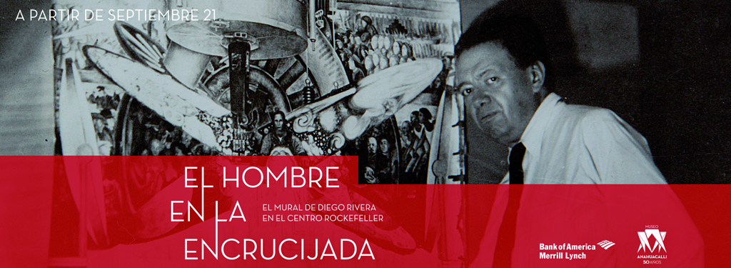

Instrucciones:

- Draw or print the animal or object that you selected in class. You may use the back of this paper, construction paper, etc. but it should be no larger than a piece of construction paper in order to fit everyone’s artwork.
- Color it (or print it in color)
- Cut it out and write your name on the back. Turn it in on Friday.
- We will be creating a mural by combining all of our art work from all 5th graders.

