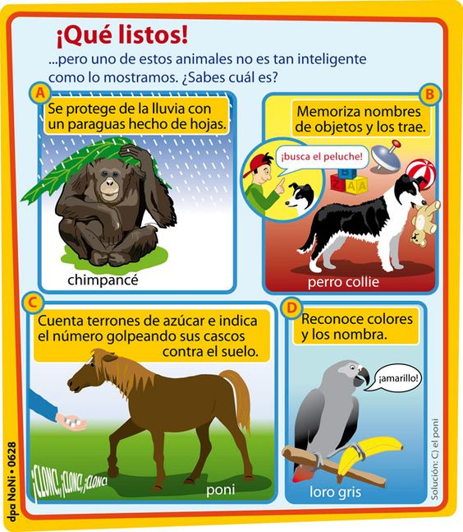

1. The title ¡Qué listos! Most likely means…
   1. How strong! b. How intelligent! c. How noisy!
2. Cognates are helpful words when learning Spanish that are similar in English with the same meaning. Which of the words are cognates? Circle all that apply.
   1. Chimpancé b. perro c. poni d. Loro
3. Based on the description and visual, what can chimpanzees do?
4. Based on the description and visual, what can dogs do?
5. Based on the description and visual, what can gray parrots do?

http://www.noticias24.com/mascotas/noticia/5395/conozca-la-inteligencia-de-algunos-animales-infografia/

Nombre ______________________________ Tarea: Practica de Leer

**Meta:** I can use reading strategies to interpret information from a Spanish text.

**Instrucciones:** Read the text about animals and answer the five questions below in English.