Me llamo __________________________ Tarea: Reading Practice
Objective: I can read to identify facts and make inferences.

Instructoins: Read what three teenagers are going to do on their trip to South America. Answer the fact question and inference question for each person.

Fact questions: These questions often use use who, what, where, when, why or how. You can often specifically underline or point to the answer.
Hints: Look for words from the question in the text to locate the answer.

Inference questions: These require more detective work and require you to use information from the text to infer meaning because the answer is not explicitly given.
Hint: Read the choices first and then reread the passage to look for clues.



Me llamo Bianca. En mi vacación en Sudamérica yo voy a la playa para relajar en el sol. A la playa voy a leer libros, escuchar música y sacar fotos del océano. Yo quiero una vacación tranquila.

Fact: 1. Where does Bianca want to spend her vacation? Underline where you found the answer in her description above.
- the mountains
- the beach
- the desert

Inference: 2. What other activity would Paula most likely do on her vacation?
- Zipline through the rainforest
- Hike in the mountains
- Do yoga while watching the sunrise



Me llamo Cruz. Me siento muy feliz visitar Sudamérica. Yo voy a participar en muchas actividades. Primero, yo voy a subir unas montañas grandes. También, voy a explorar unas cuevas ancianas y visitar la catarata más alta del mundo.

Fact: 3. What is Cruz going to explore? Underline where you found the answer.
- Ancient caves
- A mysterious island
- A famous beach

Inference: Based on his vacation plans, what type of person is Cruz?
- Lazy
- Adventurous
- Funny

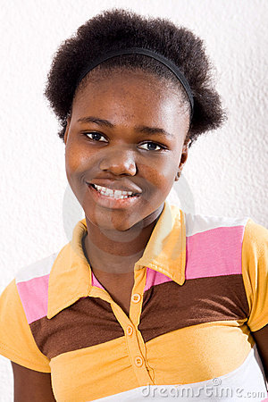

Me llamo Paula. En mi vacación yo quiero observar los animales interesantes de Sudamérica que no viven en los Estados Unidos de América. Voy al bosque tropical para buscar las anacondas, los delfines rosados, las pirañas y los monos. En Perú, voy a sacar fotos de las llamas en las montañas. También, yo voy a la Isla Galápagos para observar las tortugas grandes. Hay animales muy especiales en Sudamérica.

Fact: 5. What does Paula want to do in South America? Underline where you found the answer.
- See the animals
- Swim in the Amazon
- Mountain climb

Inference: 6. What does Paula most likely want to be when she grows up?
- an astronaut
- a firefighter
- a veterinarian

Open Ended. Who would you most like to go on vacation with? Explain why with evidence from the text. You may answer in English. Optional challenge: Answer in Spanish.

_______________________________________________________________________

