Instrucciones: Look at the two advertisements and determine which restaurant the statements below are describing. Write LP for Las Palomas, CL for Cielito Lindo or A for Ambos ().
Me llamo ____________________________________________ Tarea: Actividad de Leer

Objetivo: I can interpret information from advertisements in order to identify key information about restaurants.

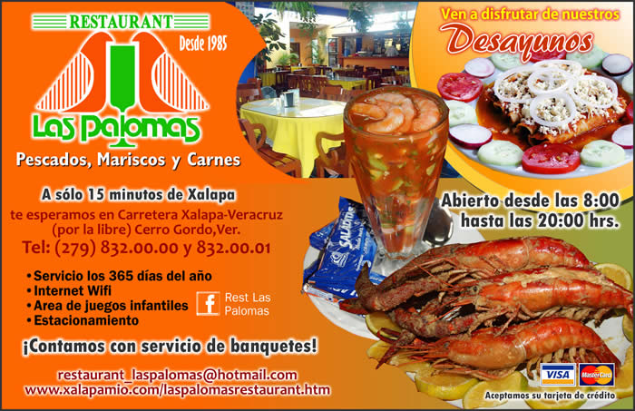

¿Las Palomas, Cielito Lindo o Ambos?
(¿LP, CL, o A?)

- Is open until 8:00 pm
- Has an area with games for children.
- Serves hand made tortillas
- Is open every day of the year
- A customer may order fish
- Serves breakfast
- Has Wifi
- Is located in Oaxaca, México
http://xalapamio.com/restaurantes/laspalomas/anuncio_laspalomas2.jpg
http://oaxaca-mio.com/cielitolindohuatulco.htm

