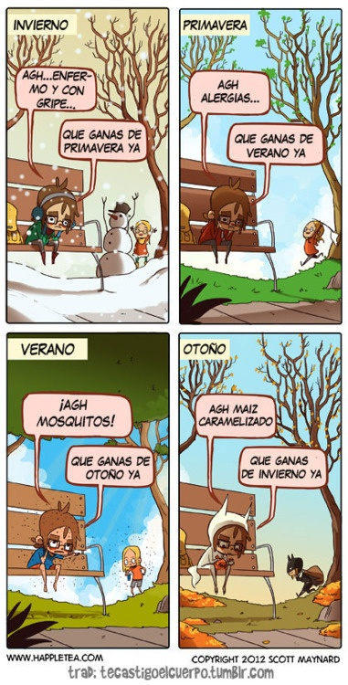

PARTE II. Each picture in the comic is labeled with a season. Write the Spanish translation for the seasons in English below.

1. Summer =
2. Spring =
3. Fall =
4. Winter =

PARTE III.

1. In the invierno comic, the word “gripe” means flu. What do you think the word enfermo means?
   1. Sick
   2. Energetic
   3. Bored
2. Based on the comic’s words and visuals, what is the main idea of the comic?
   1. The seasons go by quickly.
   2. Each season has something bad about it.
   3. Summer is the best season.

Me llamo ________________________________________________ TAREA

PARTE I. Write a month for each picture on the space provided (there are various possibilities). Optional challenge: Write a complete date instead of just the month.